Orators Report
on the 15th Degree
Knight of the East,
Sword, or Eagle
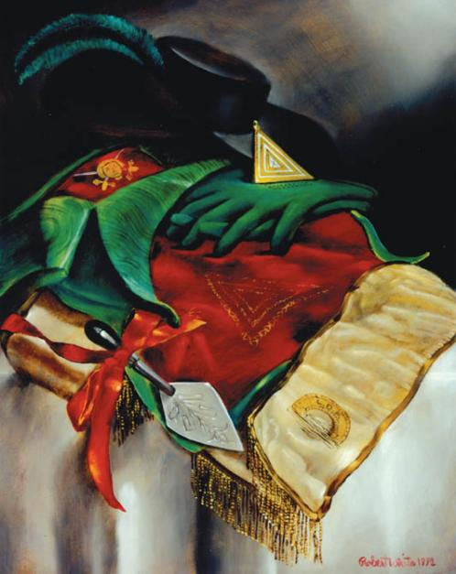
Aug 3, 2011

The apron of the 15th Degree is red velvet. On the flap of the apron is a head upon two crossed swords.

Bremerton Valley of the Scottish Rite
The Legend: The preceding degrees, until the 14° inclusive, deal with various aspects of the Hiramic legend, examining aspects such as duty, faithfulness, the knowledge and virtues that characterize a Mason.
The 15th and 16th degrees, which serve as a transition between the Lodge of Perfection and the Rose-Croix Chapter, deal with the Second Temple of Jerusalem, built by the Jews returning from the Babylonian captivity, and who brought with them a rich cultural baggage (including the names of the months in Hebrew) and also certain features of oriental mysticism, such as the belief in the after-life, which did not exist earlier in Hebrew traditions.
The 15th degree ritual tells the Biblical story of the Babylonian Captivity and the return of the captives to Jerusalem, whereon they built the Second Temple under the direction of King Cyrus.
The Settings: The Hall of the West, or First Apartment, represents the encampment of the Hebrews, in huts and tents, amid the ruins of Jerusalem and the Temple destroyed by Nebuchadnezzar. Many Hebrews are in captivity.
The Hall of the East or Second Apartment represents the Council-chamber of Cyrus, King of Persia at Babylon.
The Third Apartment represents Cyrus' Treasure Chamber. It contains great treasures including the Ark of the Covenant.
The Ritual: In the First Apartment: Zerubbabel, a descendant of Solomon, proposes to Hananiah, the Worshipful Ruler of the governing council of the remaining children of Israel:
"It is the first year of Cyrus, King of Persia, who long since promised to rebuild the Lord's House in Jerusalem. But the memory of kings is treacherous; and he has delayed until the hearts of your brethren of the captivity are very heavy. I have come here at their request to pray to the God of Israel that he will cause the king to remember his promise and set them free."
The Jerusalem governing council agrees to Zerubbabel's proposal and helps him journey to Babylon.
In the Second Apartment, the Council-chamber of Cyrus, King of Persia, Zerubbabel requests that King keep his promise to set the Jews free; and allow them to return to Jerusalem to rebuild the city and Temple.
The King, however responds to Zerubbabel: " … I have heard with interest of an order instituted by Solomon, your ancestor, and know you to be of high rank therein, and I will grant your request, upon your imparting to me the secret knowledge of that order. "
To which Zerubbabel replies: "… To faithfully keep our secrets, is the first lesson we are taught. My engagements are sacred. If I can obtain your favor only at the expense of my integrity, the Temple must remain in ruins."
While King Cyrus considers Zerubbabel's request, he directs his Master of The Palace to take Zerubbabel to his Treasure Chamber. There Zerubbabel is offered great riches for his secrets, but unyieldingly declines all offers. Upon Zerubbabel's escort back to Cyrus' chambers, the King says:
"I did but test your resolve. Your integrity is such that it should serve as an inspiration for future generations. "
King Cyrus agrees to free the people and support the rebuilding of the Temple.
To this Zerubbabel replies: "0 Great King, now truly have you proven yourself worthy to receive that which neither greed nor riches can acquire. If you will place yourself in my charge, the Order of Solomon shall be bestowed upon you."
The Lecture: The candidate is invested with the jewels, apron, and sash of the degree and their symbolism is explained. Two great lessons are taught by the Degree. The first is that liberty is achieved slowly and by painful steps. The second is that honor and integrity are absolute, not relative or convenient.

THE MORAL TEACHING: Be devoted to the holy cause of civil, political, and religious freedom; freedom of thought, freedom of the conscience, political, and religious liberty. Liberty must be fought for, and the battle is not always obvious. Few things seem so typical of society as its desire to take decisions out of the hands of individuals. But if a man cannot make meaningful decisions, he is not free.
DUTIES: Rebuild the Masonic temple of liberty, equality and fraternity in the souls of men and of nations.
FOR REFLECTION: Is equality the basis of all freedom?
IMPORTANT SYMBOLS: Green predominates in the regalia of the Fifteenth Degree. The cordon is of green watered silk. The apron is lined and bordered in green, and the regalia include green kid gloves and a green plume in a black, broad-brimmed hat. Green symbolizes the immortality of the human soul and the transcendent nature of Masonry.
The apron represents the duty of the Scottish Rite Mason to oppose and defeat arbitrary limitations on intellectual, spiritual, and political freedom. On the apron are three triangles, one inside the other, formed of chains with triangular links. They represent the three great limitations on, or enemies of, the human intellect—tyranny, privilege, and superstition. Those three enemies of humanity are opposed by the three great virtues, represented by the three nested gold triangles on the jewel of the Degree. The triangles represent liberty, fraternity, and equality as well as law, order, and subordination.
At the end of the sash is embroidered an arched bridge on which are the letters L.D.P. The original meaning of the letters is Liberté de Passer (Liberty of Passage) and Pike adds Liberté de Penser (Liberty of Thought). To be true and complete, liberty must include both the body and the mind—one must be free to move, to do, and to think.

Excerpts from The Scottish Rite Journal - March 2000
Adapted from the Spanish version of Rex R. Hutchen’s book A Bridge to Light

